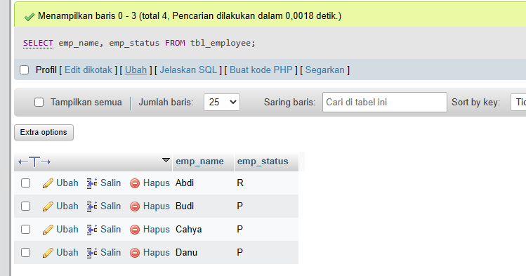

[SELECT](http://localhost/phpmyadmin/url.php?url=https://dev.mysql.com/doc/refman/8.0/en/select.html) emp_name, emp_status from tbl_employee;

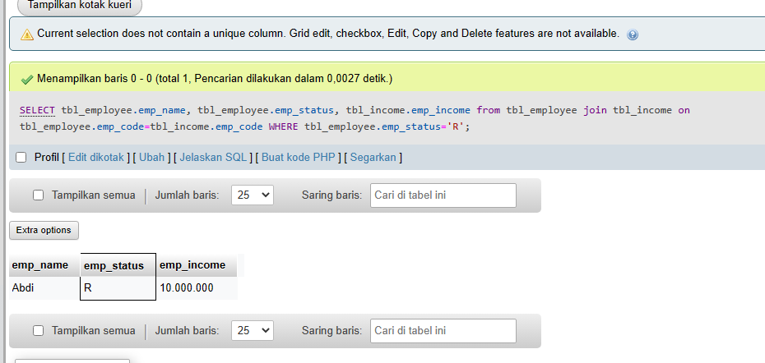

[SELECT](http://localhost/phpmyadmin/url.php?url=https://dev.mysql.com/doc/refman/8.0/en/select.html) tbl_employee.emp_name, tbl_employee.emp_status, tbl_income.emp_income from tbl_employee join tbl_income on tbl_employee.emp_code=tbl_income.emp_code WHERE tbl_employee.emp_status='R';

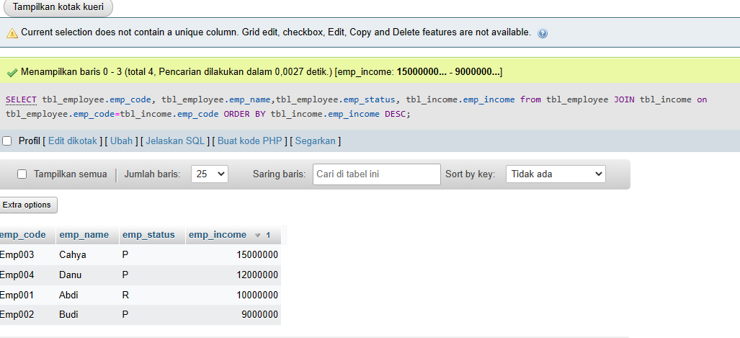

[SELECT](http://localhost/phpmyadmin/url.php?url=https://dev.mysql.com/doc/refman/8.0/en/select.html) tbl_employee.emp_code, tbl_employee.emp_name, tbl_employee.emp_status, tbl_income.emp_income from tbl_employee join tbl_income on tbl_employee.emp_code=tbl_income.emp_code ORDER by tbl_income.emp_income DESC;